**TASK- 3:** Generate a DSB-AM w/C, generate a signal with modulation index 25%, 50%, 75% and 100%

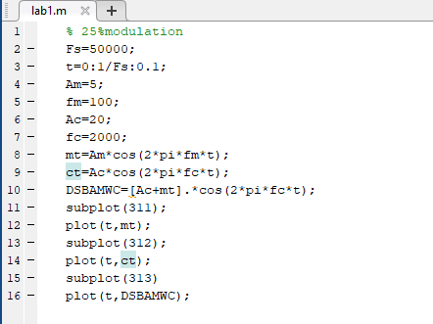

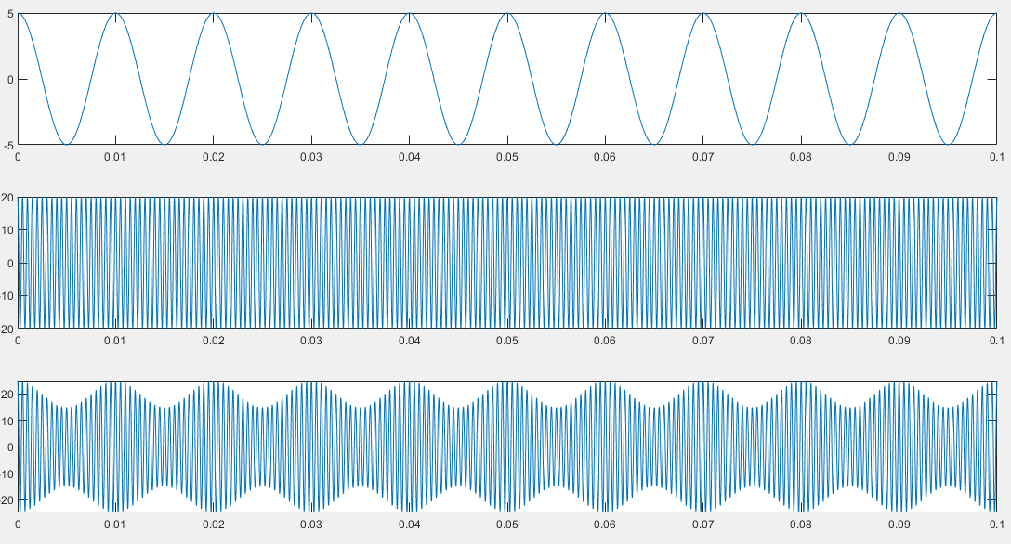

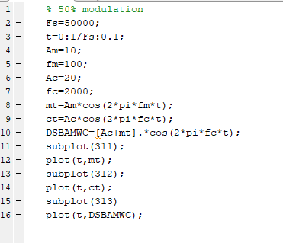

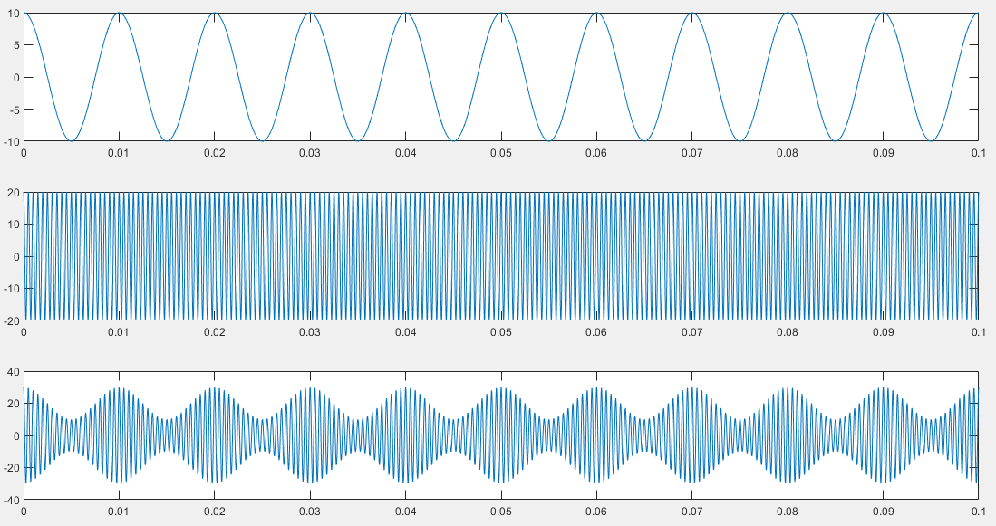

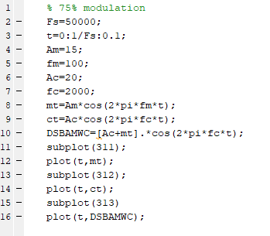

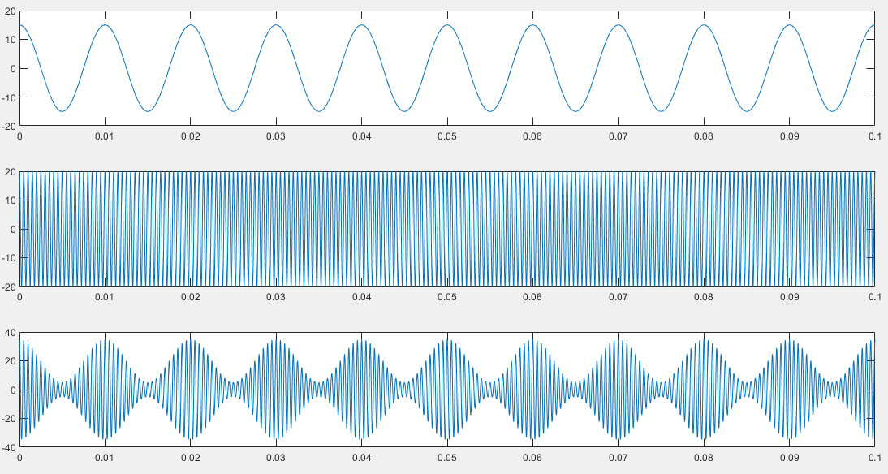

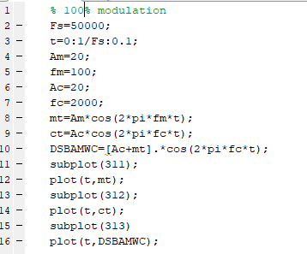

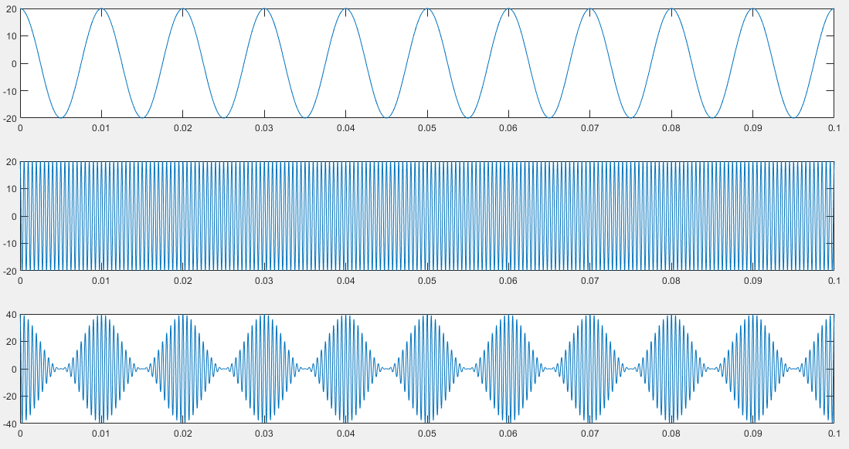

**LAB TASK- 4:** Develop a generic MATLAB function to generate DSB-AM w/C and DSB-SC AM. The input parameters of the function should be, carrier frequency, carrier amplitude, modulating signal. Use a recorded voice of 100ms duration as modulating signal.

